**Implementing Teams Group Request Governance**

Teams is a new and powerful tool provided to Office 365 customers that allows them to track work, communicate, and collaborate on projects across the enterprise. Out of the box Teams provides users the ability to create new groups at will, and when a new group is created a related SharePoint Online site is also provisioned for that new group. This can result in the rapid spread of SharePoint sites that IT and Operations teams may be unaware of, and yet still responsible for supporting.

To help mitigate this spread of content and untracked use of tenant resources, many organizations are implementing strong governance processes around how new Teams groups can be requested and created. In this example, the creation of new Teams groups has been restricted to particular service accounts which will only provision a new group after a user has completed a standardized request form, and the request has been approved by their manager.

Let’s take a look at how you can configure this workflow in your environment.

**Connectors Used:**

* [Azure Active Directory](https://help.nintex.com/en-US/nwc/Content/Designer/Connectors.htm#AzureAD)
* [Microsoft Teams](https://help.nintex.com/en-US/nwc/Content/Designer/Connectors.htm#MicrosoftTeams)

**Configuring Your Start Form**

Given that we only want people from within the organization to be able to request a new Teams group within the Office 365 tenant, first make sure that ‘Give form access to’ is set to ‘Authenticated users in this tenancy’.

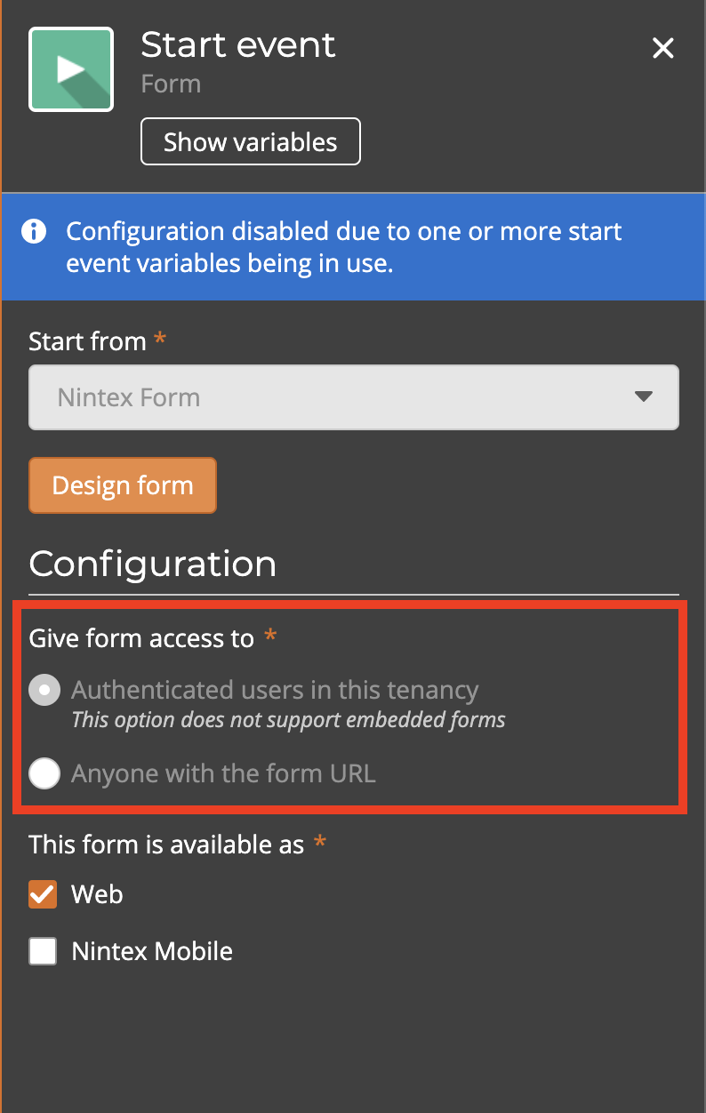

While no changes to the start form are required, if you would like to review how the controls are configured, or add additional branding to the form, select ‘Design form’ to open the form designer.

Each of the controls on the start form will relate to one of the workflow’s Start Variables. It is worth noting that if you change how you want users to delineate Member’s Emails (such as using a semi-colon instead of using a comma), you will also need to update the Regular Expression action later in the workflow to reflect this.

**Getting Manager Details and Assigning Approval Task**

As we want to make sure that the creation of a new Teams groups is approved by at least the submitter’s manager, the next step is to retrieve the manager details from Azure Active Directory. Because we are using an authenticated start form, we can get the submitters email from the ‘Start Event Context’ option within the variable menu, and then select the ‘Workflow Initiator’ object that holds their email.

Once we have the manager’s email, we can then assign the approval task to the Manager Email that we just got from Active Directory.

The task form is pre-configured with the critical fields from the start form as well as the approval Outcome that the manager must select. If you would like to update/configure the form with additional details, you can do this by selecting ‘Edit Form’.

**Creating Teams Group and Adding Owners and Members**

Once the creation of the new Teams group has been approved, it is time to actually create the group and assign the new owner and members.

The first step that we take in this template is extracting the “member” email addresses into a collection variable. Because the “Member Emails” control on the form was a Long Text control which stores the information as a string, we need to use a Regular Expression action to grab the individual emails that will be used to add the actual members to the group shortly.

With the group members now added to the collection, the workflow will now do the following things:

1. Create the team group
2. Add the owner to the group
3. Loop through the collection of member emails and add each of them to the new group
4. Add a tab to the General channel for easy access to the corporate processes

By creating the group via Workflow we can ensure that our group names are standardized across the organization.

If you would like to modify the various settings for your Teams group this can be done within the Create a Team action, in this template all options are set to Yes.

Here is where we loop through the collection of member emails and then add each one to the group.

To help ensure that all new groups are created with easy access to the corporate processes, we will create a new tab in the General channel and embed a direct link to our Promapp instance. This should be updated for your corporate environment.

Finally, we will send an email to the submitter letting them know that their new Teams group has been created with a link to that new group.

